Chapter 10, Problem 66.

At terminals a-b, obtain Thevenin and Norton equivalent circuits for the network depicted in Fig. 10.109. Take ω = 10 rad/s.

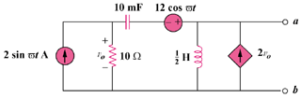

Figure 10.109
For Prob. 10.66.

